POE: Website Proposal

WEDE5020 – Web Development

Tshegofatso Makhubedu

ST10488240

Table of Contents.

Contents

1. Organisation Overview. 3

2. Website Goals and objectives. 4

3. Proposed Website Features and Functionality 5

4. Design and User Experience. 6

5. Technical Requirements. 7

6. Timeline and Milestones. 8

7. Budget 9

8. References 10

# Organisation Overview.

Mr.T Vehicle Sales and Repairs was created in 2022. Our mission is to provide quality vehicles and reliable repairs to our customers, with a commitment to exceptional service and satisfaction. Our target market is anybody who is in need of a good vehicle at an affordable price.

# Website Goals and objectives.

**Website goals:**

* Increase online sales
* Build brand awareness
* Improve customer engagement
* Improve content organization

**Key Performance indicators:**

* Unique visitors
* Page views
* Total sales
* Sales growth rate
* Social media engagement

# Proposed Website Features and Functionality

Homepage will have a few information about the business and our sales process and why should choose this business. About us page will go into detail about the founder of the business, the history of the company and the services the business offers. Then we have a Vehicles page that gives details about the cars that are available at the business. We also have a Frequently asked question which will try to answer most of the questions that are asked on a regular basis. Lastly, we will have a Contact us page, which will give details like the address, operating hours and how you can contact the business.

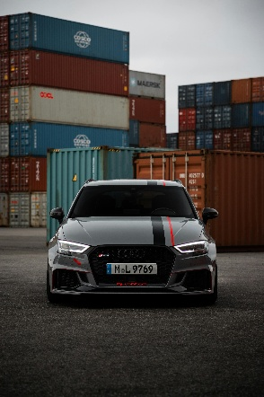 (Johnson, 2022)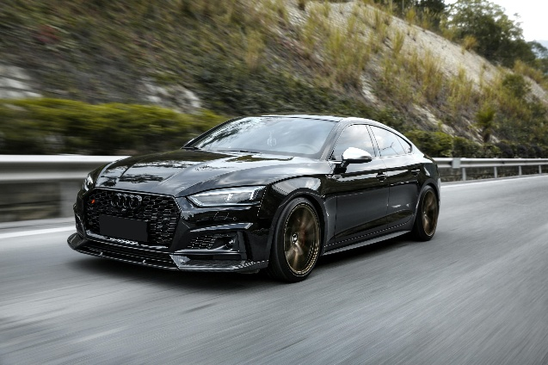 (Shields, 2023)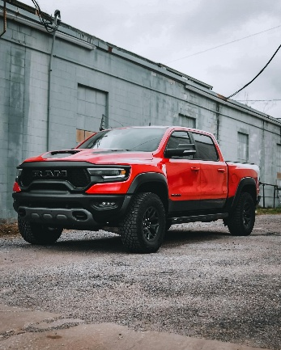

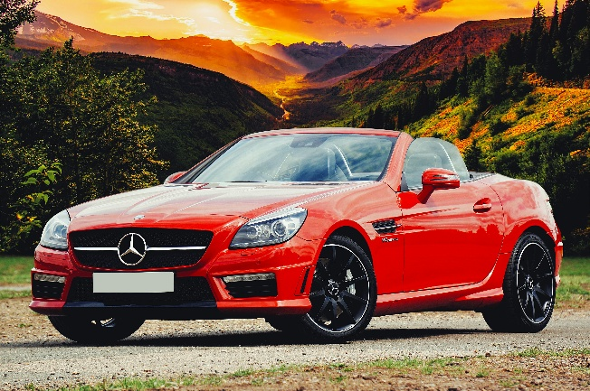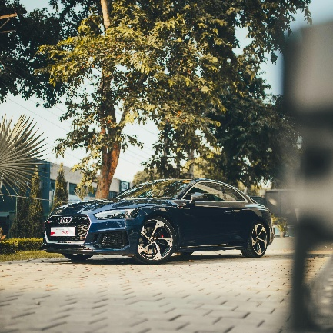

# Design and User Experience.

I used the default font of html. I have a light blue background. I used bullet lists on some of the pages. I centred all the pages and everything on most of the pages which would make it easier for the reader to read. I used different font sizes for words and captions and also made certain words like the captions and questions bold.

# Technical Requirements.

I will be using HTML for programming language and frameworks. HTML, which is Hyper Text Markup Language is basically a language used to create a web page. It is spine or the main framework that makes a web page functions. HTML will define the structure, add content, provides links and enable styling. HTML has basic HTML concepts like elements, tags, attributes and values.

# Timeline and Milestones.

**Planning Phase** - 2-3 Days.

**Design Phase** - 4-8 Days.

**Development Phase** - 9-24 Days.

**Launch Phase** - 3-6 Days.

**Post-Launch Phase** - Ongoing

# Budget

**Factors that will influence the cost of Web Page:**

* Type of Website.
* Size and complexity.
* Custom Design and development.
* Content Creation.
* Hosting and infrastructure.
* Maintenance and updates.

**Website Factors that will cost:**

Development – R4000

Hosting – R1000

Maintenance – R3000

**Other Costs:**

Domain – R900

Online Marketing – R1000

# References

# Bibliography

Bligin, I. (2023, Month 15). *mercedes white car*. Retrieved from pexels: https://www.pexels.com/photo/photo-of-a-white-luxury-car-12191122/

Freeman, L. (2022, September 26). *Mercedes car*. Retrieved from Pexels: https://www.pexels.com/photo/photo-of-a-white-luxury-car-12191122/

Johnson, J. (2022, January 16). *audi-black-car*. Retrieved from pexels: https://www.pexels.com/photo/black-car-driving-fast-on-asphalt-road-12086936/

Pilato, R. (2023, january 15). *GTI*. Retrieved from Pexels: https://www.pexels.com/search/gti/

Shields, G. (2023, January 17). *Ram car*. Retrieved from Pexels: https://www.pexels.com/search/ram%20car/